Report Template

December 31, 2015
Technical analysis – the trade that was opened on December 23 is still active. At the moment, the loss is equal 5 pips.
Psychological issues – despite the fact that Forex Tester has shown positive results for this strategy and the parameters of these indicators, I feel challenged in the whole system, especially after I have lost all the profit of the current trade.
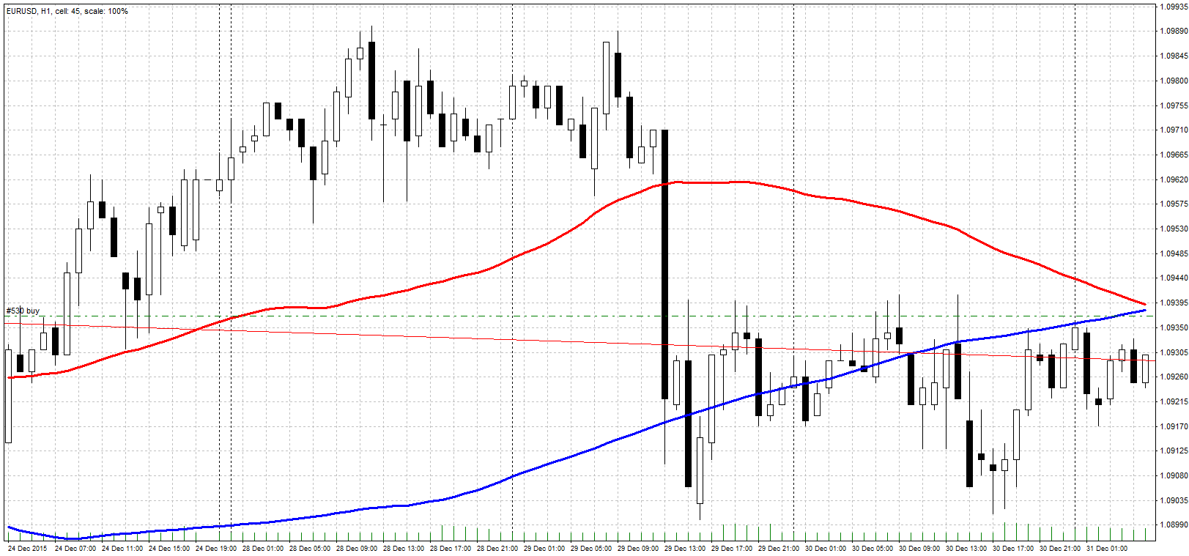

Technical analysis – at 7 am I received a signal to close the current buy order and to open a sell order. The result of the previous trade is negative -8 pips.
Psychological issues – because the trade was closed with a loss, I am eager to win my money back and therefore tempted to open the trades with an increased lotс (and risks). I have convinced myself not to do that sand to follow the previously established algorithm in a strict manner.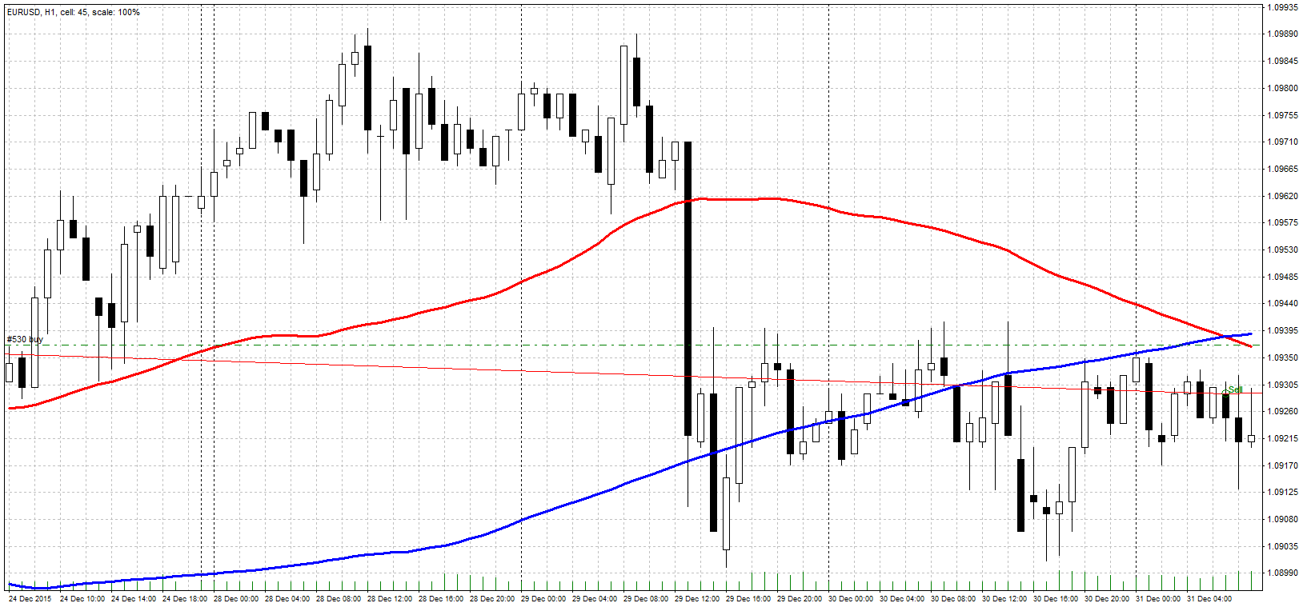

January 4, 2016
Technical analysis – after a retracement to the previous trade’s open level, the market fell down again. Now the profit from this trade is at 90 pips.
Psychological issues – it is quite difficult and boring to wait during several days and not to open new trades. I need to convince myself that Forex is not about fun and action – it is about earning money.
