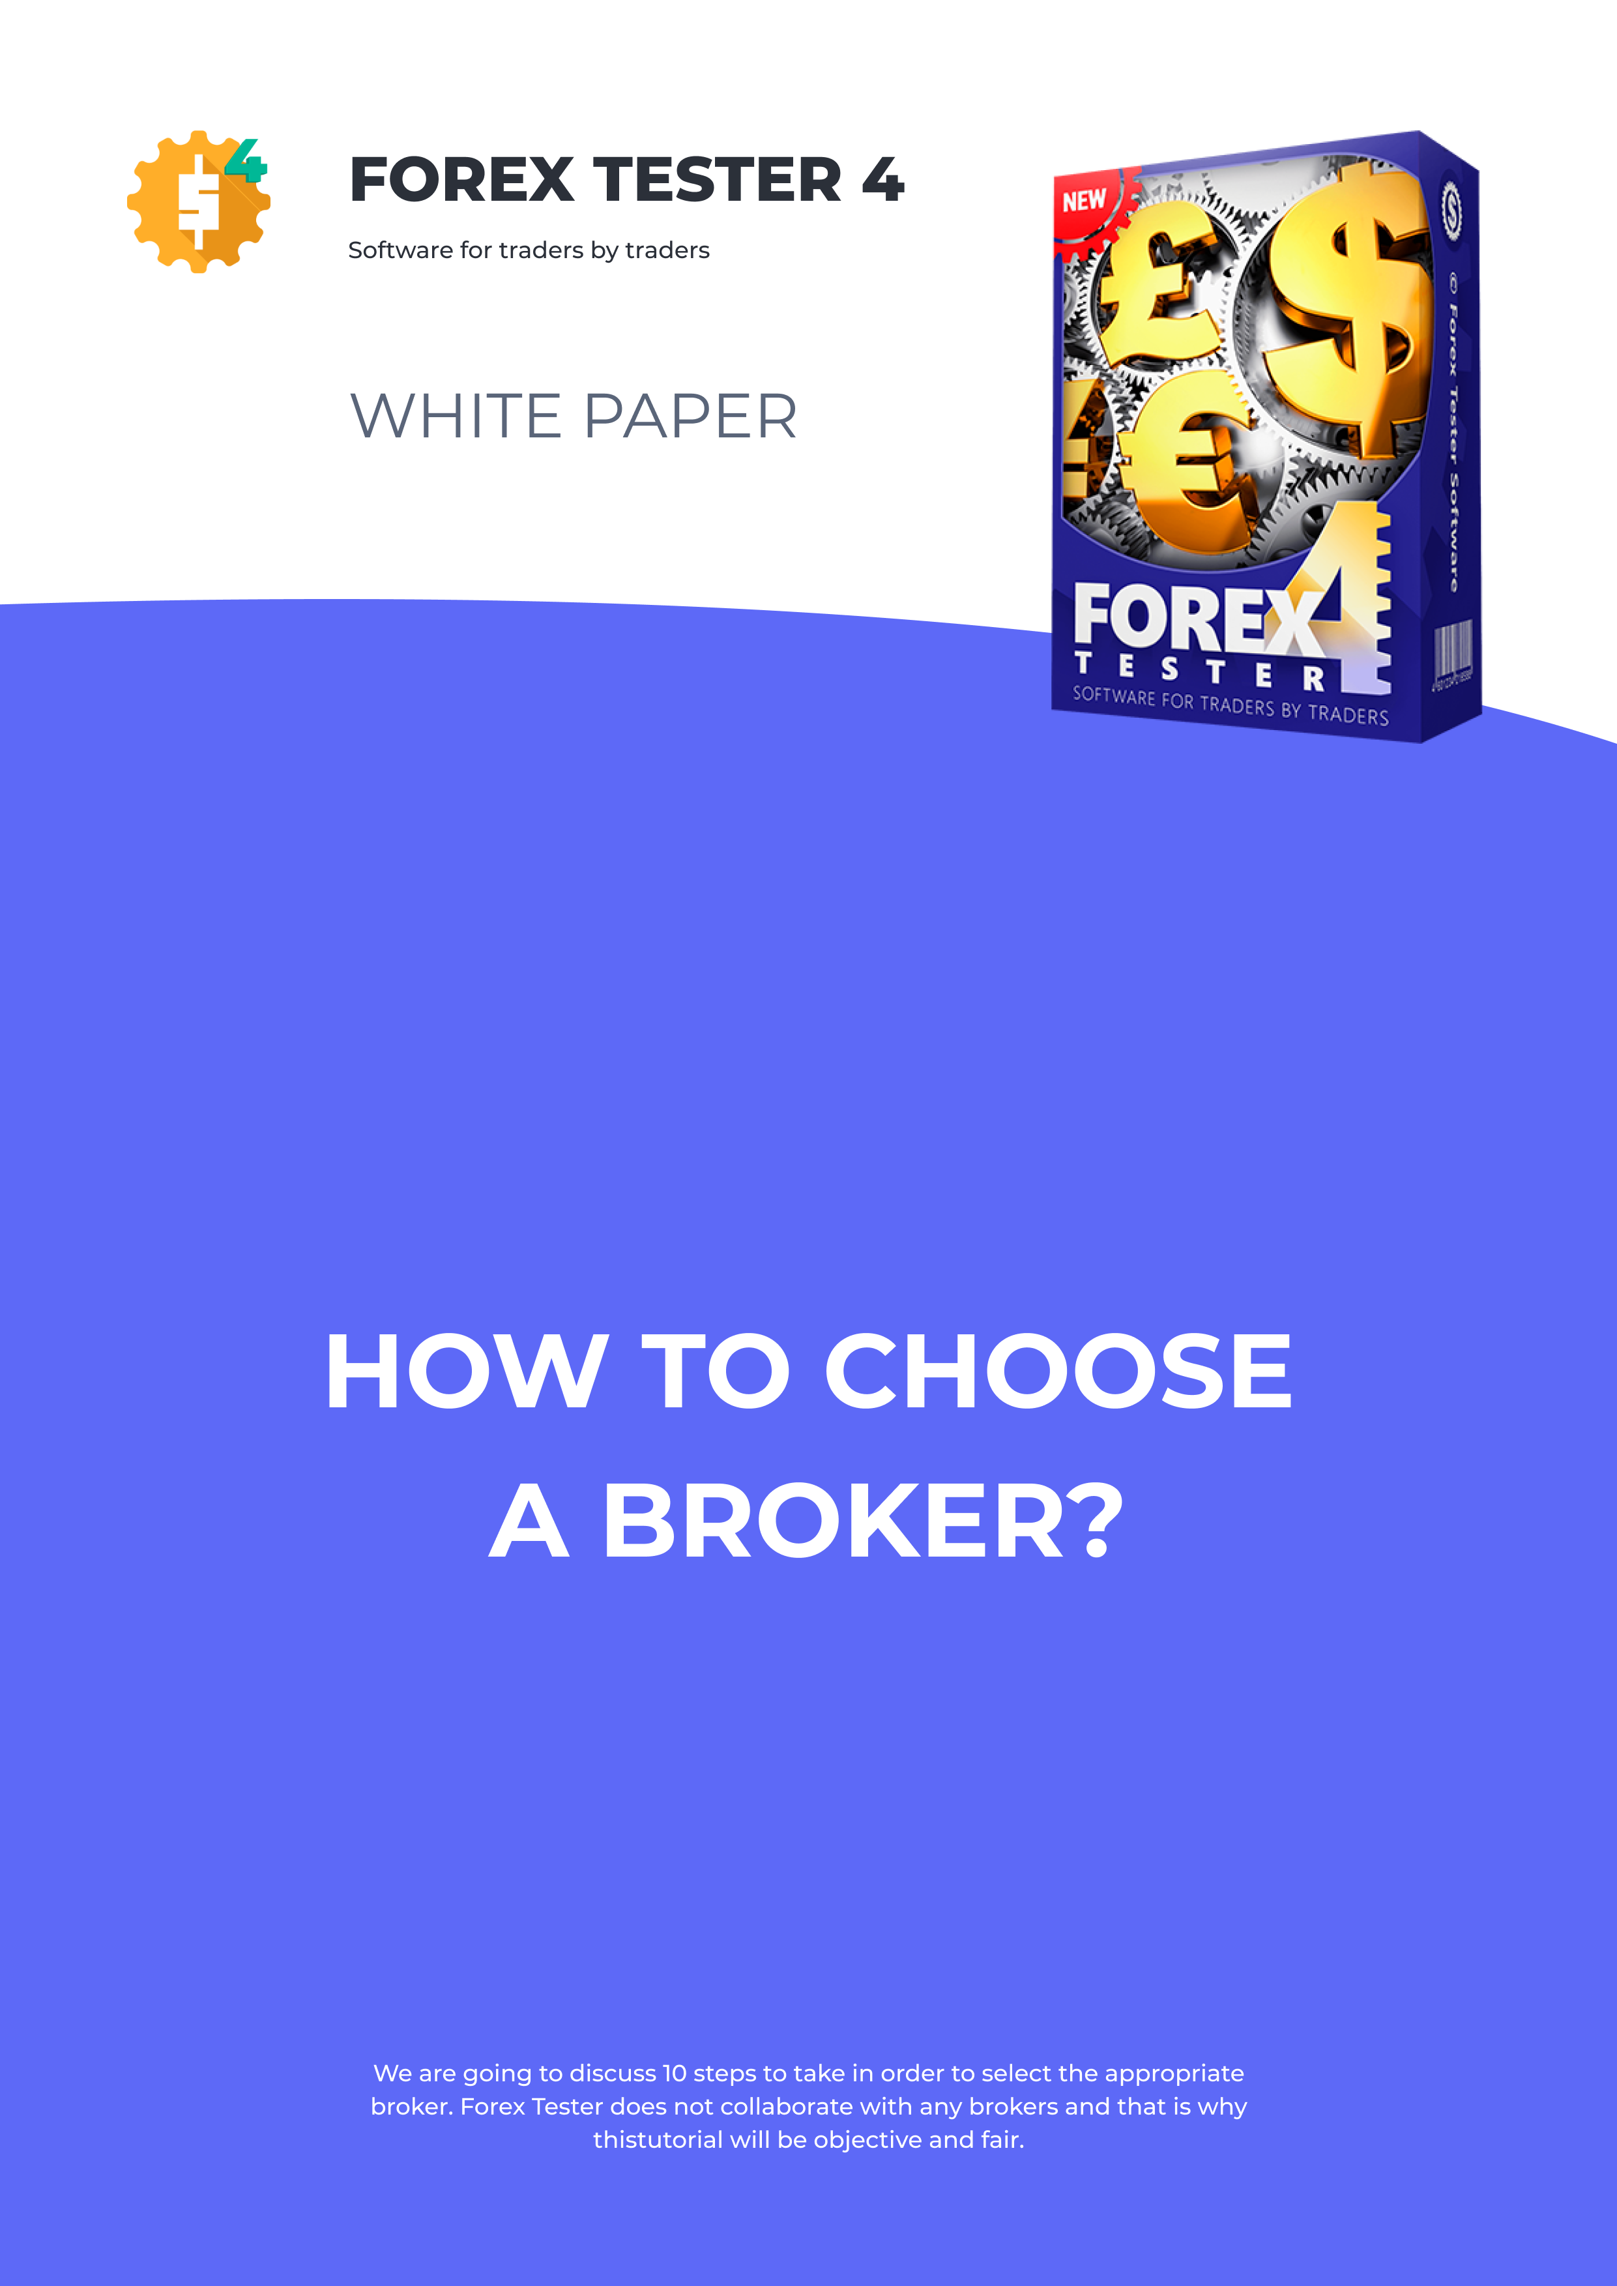

Step #1

Select a popular broker
If one broker is on everyone's lips, its services are used by millions of traders around the world, and the popularity of another broker is poor, it is obvious that one should give preference to the first option.
This does not mean that a well-known broker cannot go bankrupt (the stories of Alpari UK and MMCIS brokers are the proof). Nevertheless, the probability of bankruptcy of the popular broker clearly lower rather than the bankruptcy probability of an obscure broker.

Step #2

For how long does the broker work on the market?
It is logical to start cooperation with the broker who works in the market for many years and not to invest into a novice broker no matter which conditions it offers.

Step #3

What are the spreads offered by the broker for the currencies that matter for you the most?
To put it simple, spread is the difference between the buy and sell prices.
For example, you want to buy a currency pair of EURUSD at the price of 1.0800. If the spread of your broker specifically on the EURUSD instrument is 3 pips, you enter a trade, you are already losing 3 pips. If you open 1 order per day, 3 pips * 20 trading days = 60 points per month. Imagine that your trades are closed either by stop loss or by take profit that are equal to 40 pips. In order to breakeven, it is not enough just to close half of the trades by take profit and half by stop loss.
Opening the 20 trades with a spread of 3 pips, in this particular example you already owe
to the market 1.5 of profitable transactions (because 60/40 = 1.5). Therefore, if out of 20 trades, 11 were profitable and 9 were losing, you will earn just +20 pips, not 80.
For this reason, it is so important to choose a broker with tight spreads on instruments that are important to you. If the broker says that it has very low spreads for USDCHF and USDJPY pairs, and you are trading exclusively EURUSD and GBPUSD, it is necessary to pass such claims on deaf ears.

Step #4

What is the minimum deposit you can open with your broker?
In recent years, brokers have lowered the entry threshold for traders in the Forex market. Nowadays nobody is be surprised that you can need just $100 in order to start trading in the currency market. Moreover, in many cases $20 can be sufficient as well. Apart from the obvious positive side (availability of trading), this phenomenon has a negative side.
Traders whose deposit contains $100 do not seem to be interested to stick to the money management rules, because in this case the potential revenue to be measured a maximum at 10-30 dollars per month.
In addition, the broker that takes solely significant deposits (for example, $5,000 and not a cent less), creates an impression of a much more reliable institution compared to those brokers who give you the opportunity to start with $20.

Step #5

What is the minimum lot of your broker?
The most important question in Forex is “how to survive in the market”. This issue is related merely to the money management. A reasonable trader can afford to lose a certain fixed amount in a single trade (a popular option - no more than 2%). Given that many
traders cannot afford to have a deposit of thousands of dollars, but only a few hundred, the minimum lot value comes into play*
* As you may have noticed, there is some conflict between the Step #4 and the Step #5. The credibility of the broker with a maximum threshold for starting to trade is much higher, but at the same time, these conditions are not for everyone. If you select availability, you will be forced to accept a less reliable broker – the choice is up to you.
If you deposit $100 and are eager to risk no more than 2% per trade, you can afford to lose no more than $2 at a time. The average broker’s price change by 1-pip equals to a change in the deposit by 10 cents. It is noteworthy that to obtain this result you need to put to use the 0.01 lot size, which is the minimum for most of the brokers.
In other words, 10 cents per 1 pip is a minimal risk, and it's a too big risk. Setting a stop loss at 50 pips, you will be risking with $5 and to stick to the plan to risk with no more than 2% in a trade, you need to have a minimum initial deposit of $500.
While selecting a broker beginners should also pay attention to whether the broker offers micro lots.
Micro lot is a lot, which makes it possible to venture with 10-100 times less resources compared to regular lot sizes. Of course, along with the risks your income potential is reduced by the same factor. Do not rush to dismiss the possibility of trading on cent accounts because it is a necessary step while transitioning from testing strategies on the simulator and going to trade on a live account with large infusions of cash.
When you test the strategy on a simulator (for example, Forex Tester), you do not risk anything and can open trades based on your trading algorithm. Once you go to a real account, it is likely that the possibility of losing the real money (as well as the opportunity to earn), can influence your trading style in a negative way.

Micro lots allow smoothing this transition – kind of, like you are trading on a real account, but at the same time you risk with 50 cents per order. Losing a half of the buck in a trade should not be scary at all but still it is real trading.

Step #6

The leverage size
The popularity of Forex is largely due to the presence of a huge leverage, provided by the broker. In the stock market, if you have $100 and the stock costs $1, you can afford to buy 100 shares. In the Forex, if you have $100 and the leverage size equals 100, you can afford to buy $100 * 100 = $ 10,000 – an enormous opportunity to get rich very quickly or lose everything in a few minutes to hours. Beware of brokers who give you too high leverage values.

Step #7

The speed of sending/receiving information
The response of your broker’s software is a strong pro or con argument. If you place an order, you can expect that it will be executed almost immediately. Sometimes, every fraction of a second in the market (especially when the most important macroeconomic news is released) – is the money you could potentially win or save. Pay a very close attention and consider in your analysis the response speed of the broker's server to your orders.

Step #8

Data quality
When you have tested the trading strategy on the Forex simulator, you received precise statistics of the trading system’s behavior on historical data. Joining the real market, you need to start trading with the broker who provides the high-quality manipulation free data. Sometimes inaccuracy in a few points can significantly affect the balance change of your deposit: a trade can fail to reach the anticipated take profit or vice versa, the stop
loss can be activated a few points (not even pips) earlier than it happened in reality. In both cases, you lose money.

Step #9

Country of broker’s incorporation
It is important to realize that brokers, registered in the offshore zones, should be avoided, whereas the preference should be given to those brokers, which offices are allocated in "transparent" areas.

Step #10

Does the broker offer the Forex training before you open an account?
Nowadays too many brokers offer the Forex training. It has a beneficial impact over their sales in two ways:
1. It increases the credibility factor from the potential client. We all feel more trust to those who unselfishly help us.
2. It improves brokers’ ranking in the search engines. The more qualitative content is on the site, the more users get on this site itself by entering any search query. As a result, the more potential clients find out about the broker.
It is important to understand that you, as a trader, deserve a free education. We think you will agree that there is a huge difference between a broker that offers you the training only after you open an account, and the broker, which have a lot of useful information for the site’s users no matter if you already belong to their clients or not.

Conclusion
Choosing a broker is probably the most important issue for every Forex trader. You might have a solid and profitable strategy or you can have access to the investor password of the trader who has such a trading system, but if the broker in untrustworthy then you will never be able to succeed.
Be very careful while selecting the broker:
- consider all above-mentioned key parameters
- make your own research
- compare as many brokers as you can find
- read attentively the Agreement that you are about to sign
Once all that done, start trading/copying signals and become a successful trader.

