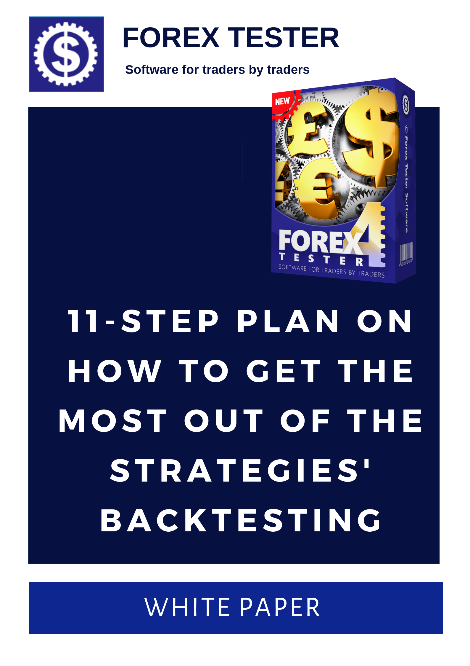

Step #1

Pick any strategy you like from the "10 simple free strategies" file
The file is issued to everyone who has purchased a Forex Tester license. There is no need to look for other trading methods until you have tested the proposed 10 options. If none of the existing methods works in the long run on your instrument, the data period and time frame, only then you will need to look for another trading method.
You can get the “10 simple free strategies” PDF file after you purchase Forex Tester

Step #2

Get a strict trading algorithm and stick to it
The real trader is an operator of his (her) trading system. Improvisation is good for people who work in creative business (actors, artists and so on). Trading is a routine occupation and it does not tolerate deviations from the plan. The biggest problem of probably any trader is to leave the ego aside and focus on making money rather than on proving your rightness. Once you make this shift in your mindset, you immediately reduce the pressure from yourself. If you followed your trading algorithm step-by-step and you got a loss, it proved that the system did not work, and this loss had nothing to do with your personality.
There are no good or bad traders. There are good and bad trading strategies. There are people who always follow all of the rules of their strategies and people who do not have the discipline.
If you have a clear plan of what to do and you follow it religiously, then after a certain period of time you will be able to say what is working in the Forex market, and what is not. If you did not have any plan, then how were you supposed to determine what led you to the loss/profit? How then to repeat your success and multiply it consistently? How to avoid the things that did not work in the past and therefore would not perform in the future?

Step #3

Proper money management
The risk calculation is what distinguishes a novice trader from an experienced one. There is a considerable amount of trading systems which are based exclusively on the money management (they do not have any justification from the technical analysis point of view and yet they can make profit). If a trader knows the exact amount of money that he (she) can afford to lose in one trade and the maximum amount to lose for the entire month, if a
trader strictly adheres to these rules, this trader will at least remain on the market for a long time, and at best will succeed in the long term.
Read more about this step in the «How to calculate risks" PDF file

Step #4

Keep a detailed trade log
"Show me a trader with good records, and I'll show you a good trader" Alexander Elder.
Trade log involves 4 must-have components:
• A summary table of all trades.
• Capturing screenshots of all the trades without any exception.
• A detailed description of the orders placing (opening, stop loss, take profit, closing the trade) – in other words, why did you open an order at that point of the market, why did you place a buy limit with a stop loss that was equal to 40 pips, why did you set a take profit at 80 pips, etc.?
• A detailed description of the psychological component. The hardest thing for a trader is in the difficulty to follow his (her) trading system and not to add anything to it from himself (herself). Writing down your thoughts and emotions while trading (testing) is a
wonderful tool of introspection that helps to sort out what really moves you in the market.

Step #5

Backtest strategy manually on a significant sample of data
Typically, traders make conclusions about the profitability of their trading systems too soon. They open several orders and if all of these 2-3 trades have brought a profit, traders enthusiastically get to open a massive amount of trades on a real account. On the other hand, if the orders were closed by Stop Loss, a complete disappointment in the entire trading system follows those several losing trades. A few trades are an excessively small sample from a statistical point of view. In order to start judging whether the trading system is able to bring profit/loss, you must open a minimum of 100 orders, without missing even a single pattern. Ideally, you want to test the strategy on thousands of trades using no less than 5 years of historical data.

Step #6

Automate you trading strategy
If your strategy has shown excellent results on EURUSD since March 4, 2007 by March 4, 2009 on the H1 time frame, it does not necessarily guarantee that the same strategy will also give profitable results on another instrument, data period or a different time frame. Testing of such a huge number of variations manually is an extremely difficult and time-consuming process. As an alternative to manual testing, one can create Expert Advisers (EAs). Any EA requires the efforts of experienced programmers and therefore costs some money, but the amount spent on the creation of an adviser cannot be compared to the enormous timesaving.

Step #7

Use the "Strategy Optimizer"
"Strategy Optimizer” is a unique feature built into Forex Tester, which allows you to test the whole range of parameters. You can set:

• the initial value of any parameter at a certain point;
• a step change of the parameter;
• the final value of the parameter.
Example. Let’s suppose you have an expert adviser that opens trades at the 2 moving averages crossover. You always set a stop loss to every single trade of yours but you do not have a clue, which value will give you the best outcome. To discover it, you can make use of the “Strategy optimizer” and specify the initial value (let’s say it will be 20 pips), a step and the final value (for example, it equals to 50 pips). The program starts backtesting all the data from a selected period with a 20-pip stop loss, automatically opening and closing all of the orders. Once the data comes to an end, the program captures the result obtained when the stop loss is at 20 pips, nullifies it and gets to the starting point of the test changing the size of the stop loss from 20 to 21 (as a step equals to 1, each new cycle will increase by 1). This cycle will run for 31 times until the software finishes the test with a stop loss of 50 points.

Step #8

Statistical analysis for identifying the most profitable strategy’s parameters
• Export Statistics from Forex Tester to Excel
• Install a “Descending” filter for all the data
• Find out which value of the parameter (in our case it was a stop loss) gave the best results.
Such analysis often leads to unpredictable results. For example, you can see that your strategy demonstrated the result of +5,218 pips on 5 years of historical data with the 32-pip stop loss. However, the stop loss of 33 pips could give a significantly worse result of +1,592. At the same time, the stop loss that was set at 31 pips could give even a negative result (for example, -312). That is why it is so important to test everything because every tine parameter change can influence the overall result of the trading system dramatically.
In addition to the stop loss altering, any kind of settings can be changed as well:
• Take profits
• Indicators’ periods
• The distance in pips from the signal appearance until the actual order opening
• And much more

Step #9

Start trading on a demo account with a minimum deposit
Once you are convinced in the profitability of your strategy on historical data, it is time to go to the demo account. The essence of this particular step is purely psychological: you no longer need to receive confirmation that the strategy works because even if you trade on a demo for a year, the result will bring you a less significant statistical confidence compared to the results received in Forex Tester. The main goal of using the demo account is raising the discipline: open the orders only in accordance with your trading system without tolerating even a minor deviation from the previously confirmed algorithm

Step #10

Run the "Statement Processor" and analyze the demo account’s trades
Once you have opened a sufficient number of orders on your MT4, you can export the file from this trading platform into Forex Tester. After that, all of your transactions will be opened and closed exactly at the same place, as it happened while trading. This allows you to look at your trading from the side and gives the opportunity to learn a lot about yourself as a trader. You can look at the accelerated record of your trades; you can stop the chart movements or speed up them even more. Such an analysis is another powerful step toward polishing skills in Forex trading. It is one of the best ways to improve the psychological factor of your trading.

Step #11

Improve your trading system even more
Testing is never too much. Even if you have found a profitable strategy with the help of Forex Tester, you can still improve it and it is unlikely that one day you will come to the point where the improvement of your trading system is no longer possible. Always keep testing: firstly, the renewed results will bring you more profit, and secondly, testing is one of the most interesting and breathtaking activities.

